*Start a new Python project folder … do not reuse the previous workspace … As with any keyboard-driven console-like environment, developing muscle -memory for the common commands is also part of the learning curve.*

CSV Dataset Cleansing and Analyzing

* Create a folder in your desktop
* Copy “data_with_headers.csv” from Canvas to this newly created folder
* Create a Python 3 program from within this newly created folder
* Rename this untitled program to “Import Data and Analyze”
* Import two libraries: numpy and pandas
* 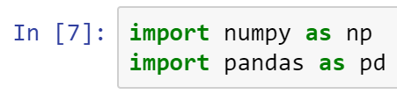
* Read the csv file that you just copied from Canvas
* 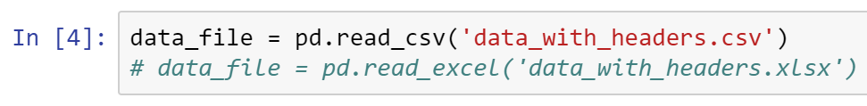
* Note in the comments above how you would read an excel file
* Printing the first 3 rows of the file
* 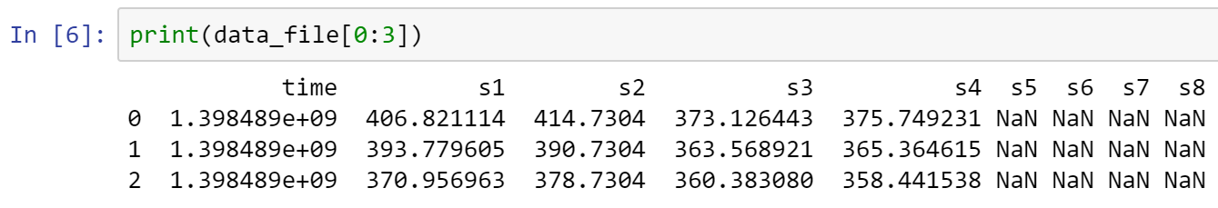
* Note that the last four columns are not-a-number (sensors s5,s6, s7, and s8 are broken)
* Now, it is time to cleanse (parse) the data
* First, extract the time column from the csv file
* 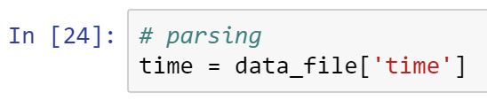
* Next, extract the readings of the good sensors (s1 through s4)
* Also, verify that you did it right by test printing the first 6 rows
* 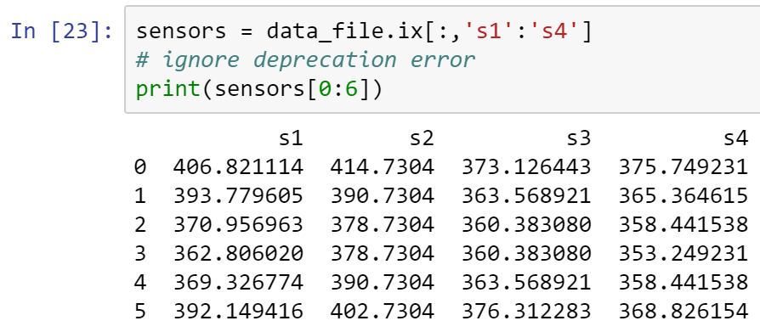
* Then, make time start at zero, and print the first 3 rows to verify correctness
* 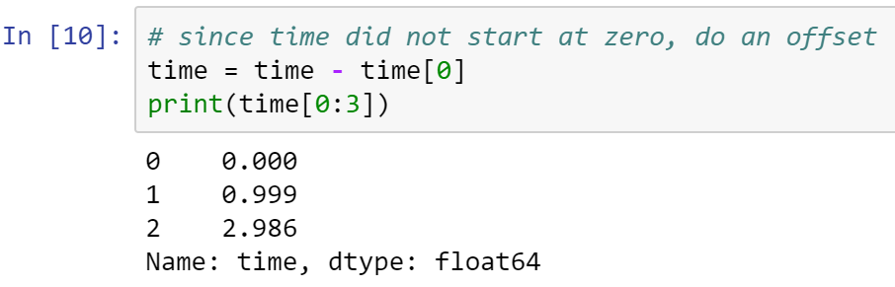
* Now, calculate the averages of rows and columns, and check your work
* 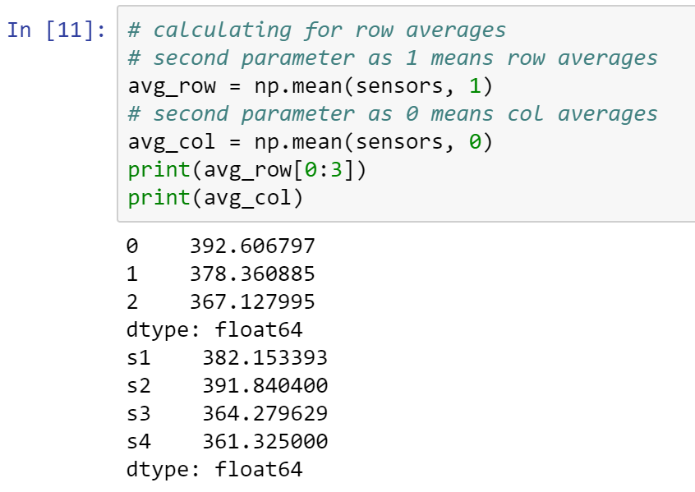
* It’s time to put these data together and create a new cleansed file
* Print the first 3 rows to verify the format of the cleansed file
* 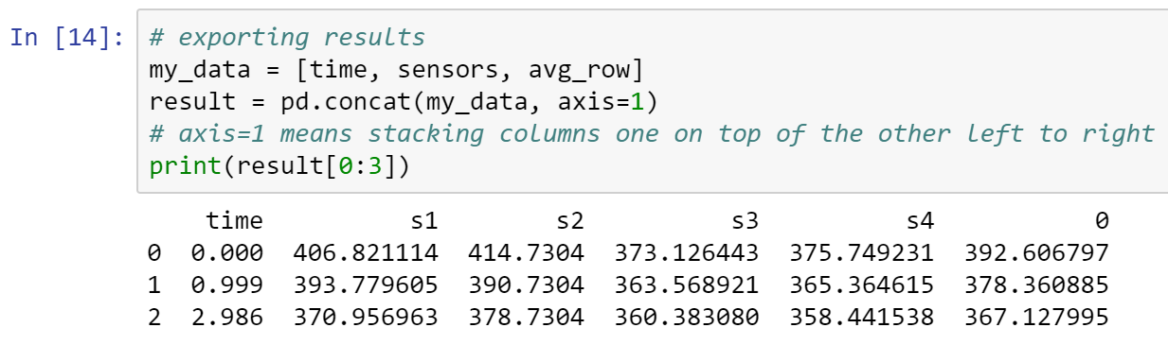
* In the new file above, time is the first column, followed by the four good sensors, and the last column is the average of the row
* axis=1 means arrange these columns one after another starting from the left
* Once the format of this new scrubbed file is correct, you can save it in different format
* 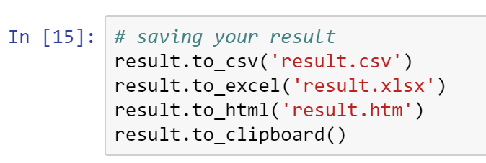
* These files will be stored in the same folder where your Python program is
* Open the csv using notepad, xlsx using Excel, htm using a browser, and then open word and do [CTRL]+[V] to copy what is in the clipboard to your document
* Paste all your outputs below:

_______________________________________________________________________

* Time to try plotting the results
* Import pyplot
* 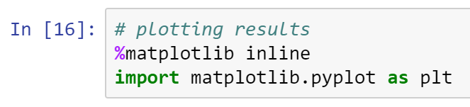
* Creating the figure
* 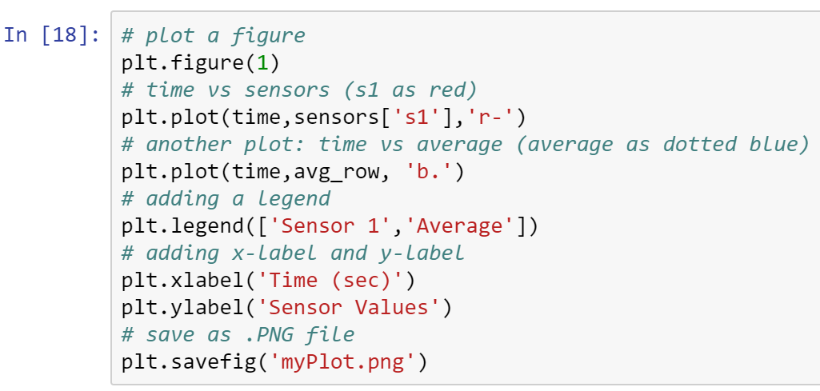
* 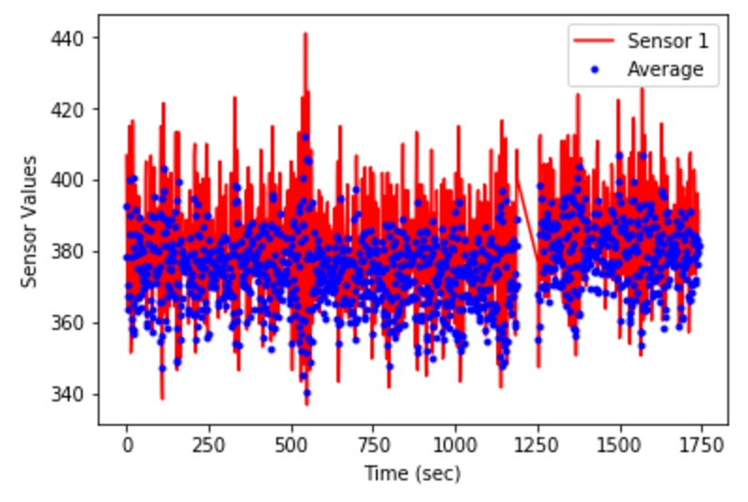
* Based on what you have learned from this exploration, identify two ways how you will use this knowledge to give your organization a leading-edge? In other words, what two things you can do to take advantage of the new skill you just gained?
* (1)
* (2)
* Research in the net and find the best place to read documentation regarding (a) numpy, (b) pandas, and (c) pyplot. Paste your favorite links below:
* (a)
* (b)
* (c)
* *Go to the discussion board and share the two ideas you have above and the three links to your peers.*
* All submissions should be separate from other exercises and quests. Please do not lump all your answers into one document and re-using that same workspace to gain multiple points. Thanks.
* Place your name at the bottom of your code, download your Python program in html format, and submit your work in Canvas.